Use Telegram as you your IOT platform

Most IOT platforms online cost some money. They do let you use their platform for free to a certain extent, but you still need to have something that you own somehow on the cloud.
One of the solutions I found nice and free and does satisfy my requirements is Telegram. It is an messaging app similar to Whatsapp, but has the extra feature that it allows you to create a chat bot of your own. They also have an API the you could use to program that bot.

We are going to use the CTBot Arduino library to mediate us with the Telegram API.
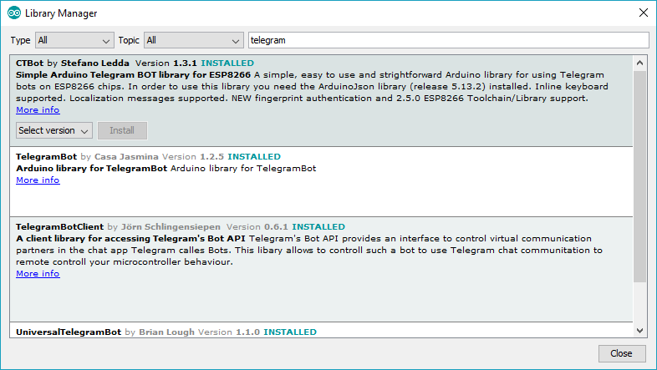
Most of the Arduino Telegram libraries require ArduinoJSON library V5 ( please downgrade from v6 if you already have it).
Before you start programming your ESP to interface to Telegram, you have to ask nicely the Telegram service to create you a bot you can control through an API-Key.
In your Telegram chat, look for the user: “BotFather” :

Then type in this sequence:
/start | optional
/newbot | Enter a name for your Bot. Whatever you want to call it.
 | Then enter a Unique name of the bot user but has the suffix “bot”. Be creative as this has to be a unique username.
 | Now you will have a URL link to your bot and an API token. Keep that token safe somewhere as this is the key to your bot.

you could edit your bot and add a picture to it if you want.

Try the “echoBot” Example
Fill in the WIFI SSID and pass.
Fill in the API token you got from the BotFather in “myToken”
compile , upload and add a chat to your Telegram for that new Bot using the unique name you created.
Send the bot any text and the board/Bot will echo it back.

Try the “lightBot” Example:
Modify the sketch like the last example and then also modify this line as follows.
uint8_t led = BUILTIN_LED
compile and upload
Send the following in the chat: “LIGHT ON”
And admire your creation.

Try the “inlineKeyboard” Example:
Now you need more than just send text and get a response back. You need an interface for your project, just like the one you saw in Blynk.
Telegram has the ability for the bot to send back an inline keyboard:

Which is ok if you want to interact with buttons instead of text.
Modify the sketch like the last example and then also modify this line as follows.
uint8_t led = BUILTIN_LED
compile and upload

Adding Security
Now you don’t want your bot to execute the commands of everybody on Telegram . Right ?!
You have to identify your chatID and add a condition around your message processing code to only execute the code if the :
msg.sender.id==<yourChatID>
To find your chat id, call this bot: https://web.telegram.org/#/im?p=@chatid_echo_bot
Or simply return “msg.sender.id” in the Serail.println() or the chat it self. Then modify your code accordingly.
You can find more about the CTBot api from theit github page:
https://github.com/shurillu/CTBot/tree/master/src

